Viewbook;

***The friendliest campus in The South.***

**Our Students Are Going Places**

From the moment you step on the campus of Jacksonville State University you’ll discover that you are not the only one invested in your future. For 133 years our focus at Jacksonville State University has been on one thing – getting you ready for where you are going.

**Popular Programs**

**Feature One**

* [Biology](http://www.jsu.edu/biology/)
* [Business](http://www.jsu.edu/ccba/)
* [Criminal Justice](http://www.jsu.edu/criminaljustice/)
* [Education](http://www.jsu.edu/edprof/)
* [Exercise Science and Wellness](http://www.jsu.edu/edprof/hper/esw.html)
* [Nursing](http://www.jsu.edu/nursing/ms_nursing.html)

**Academic Schools**

Through our six undergraduate academic schools JSU’s mission is to provide distinctive educational, cultural and social experiences for a diverse student population. As a learning-centered university, Jacksonville State University strives to challenge students academically in a responsive environment, meeting students' educational, career and personal goals while seeking to produce broadly-educated graduates that are prepared for global engagement.



Arts & Humanities



Business & Industry



Education



Health Professions & Wellness



Human Services & Social Sciences

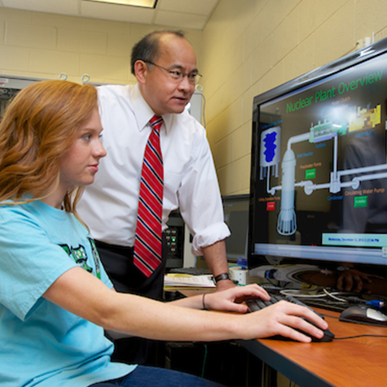

Science

Online Education

Online courses are designed for motivated individuals needing flexible scheduling of course activities. JSU offers a variety of courses and thirty-five online degrees and programs from which students can choose.

***An affordable investment to live, study and network***

**Invest**

JSU is committed to providing a quality education for an exceptional value by maintaining affordable tuition and offering [scholarship opportunities](http://www.jsu.edu/finaid/scholarships/) for our students.

* The JSU Title IV Code for FAFSA is 001020.
* Financial Aid preferred deadline is MARCH 15.
* The Scholarship Application Period is OCTOBER 1 to MARCH 1.

**Tuition**

Estimated cost based on fulltime student. For more information please visit the [Office of Student Accounts](http://jsu.edu/bursar/fees/index.html).

|  |  |  |
| --- | --- | --- |
|  | **In-State** | **Out-of-State** |
| Tuition | $7,416 | $14,832 |
| University Fees | $750 | $750 |
| Housing | $3500 | $3500 |
| Meal Plan | $3080 | $3080 |
| Books | $1,000 | $1,000 |
| Total | $15,746 | $23,162 |

**Live**

JSU promotes a campus community where you can live, learn, and grow as an individual. Our campus will be your home away from home, convenient to your classes and campus activities.

**Housing**

* Four residence halls for freshmen.
* Complimentary utilities, laundry, and wifi.
* On-campus parking available at residence halls.

**Student Life**

* Be involved in one or more of our 100+ student organizations.
* Studies show, students involved at JSU have a higher GPA, retention rate, and graduation rate.

**Campus Eats**

* Four meal plan options for residential students to choose from.
* All-you-care-to-eat buffet at Jack Hopper Dining Hall.
* Flex $$$ to use at other on-campus dining facilities.
* Commuter dining plans available.

**Counseling & Disabilities Support Services**

We believe that getting to Where You’re Going means having someone there to support you, no matter what your personal challenges may be. Our team of licensed counselors is there for you, 24/7, if you’re dealing with a personal crisis or just need some encouragement. And if you have a documented disability, rest assured that our support staff will give you the assistance you need to succeed in the classroom.

**University Police Department**

We take your safety very seriously at JSU. That’s why we have our own police department that patrols campus twenty-four hours a day, seven days a week. You’ll find emergency phones around campus and a direct number to our police department in the unlikely event of an emergency. Our officers can take you to your destination on campus after dark at no cost. They’ll even unlock your vehicle if you leave your keys in it.

**Study**

Honors Program

The Honors Program is designed for outstanding, motivated students, and courses are taught in small classes by some of JSU’s most innovative and engaging faculty. Honors courses are offered in the arts, humanities, sciences, social sciences, and mathematics.

Academic Support Services

At JSU, you’re never far away from people who can give you some extra help in your classes. We offer year-round tutoring in many courses at no cost. There’s even a writing clinic if you want to brush up on your English skills and a math lab to help you with those tricky equations. And if you’re an expert you can help others as a paid student tutor at our Academic Center for Excellence.

**Network**

Career Services

Gain a competitive edge in the 21st century job market by taking advantage of our free student career services. If you can’t decide what career path to take, our staff will help you find options for success. We’ll help you write an eye-catching resume that highlights your unique skills. And if you’re looking to get your foot in the door at a company in your degree field, we’ll guide you to internship and co-op opportunities.



"This is our third year to have recruited and hired summer Interns from JSU. This program has been very successful and I have found the students from JSU to be equal to the other Intern students we hire from other colleges from all over the U.S. JSU students are bright, eager to learn and have a strong work ethic which is all you can ask of an intern. I would like to also say the staff at JSU we work with to recruit and hire our interns are super helpful and very professional in their dealings with me and our staff at Jack Daniel's. The Internship program has been a win win for JSU and Jack Daniel's."   Steve May Director of The Lynchburg Homeplace Jack Daniel's Distillery

***Athletics***

Jacksonville State athletics continued to dominate on the field of competition as the Gamecocks won numerous OVC Championships and advanced to NCAA Championships, while also excelling in the classroom, during the 2016-17 year.

**Intramural and Recreation**

Sand volleyball, bowling, dodge ball, flag football, inner tube water polo, racquetball and more!

[Learn More](http://www.jsu.edu/recsports/Intramuralsports.html)

**Marching Southerners**

* Nationally Recognized.
* Wind and Brass players.
* The JSU Drum Line
* The Marching Ballerinas (Dance Line)
* The JSU Color Guard (Flags, Rifles, Sabres)

Learn More

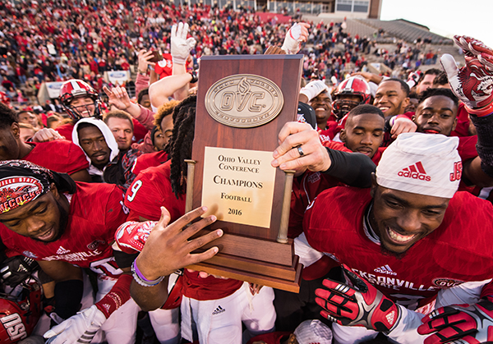

Jacksonville State defeated UT Martin in a 33-7 blowout victory at Burgess-Snow Field to claim their third consecutive OVC championship and the league's automatic berth in the FCS playoffs.

**How to find us**

Visiting campus is the best way to decide if JSU is where you're going. Tours are given Monday-Friday by appointment and are not available on university holidays or breaks. One visit and you’ll be prepared to make yourself at home, at least for the next four years.

[Schedule a Visit](http://www.jsu.edu/admissions/campus-tours/index.html)

[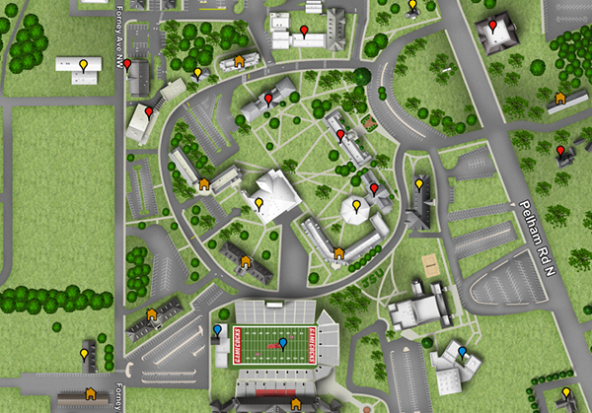](http://www.jsu.edu/campusmap/)

[Check the campus JSU map.](http://www.jsu.edu/campusmap/)